Personalizing Team Home Pages

The Team Home page includes Team Info, News, Facebook feeds, and much more! Team Settings allows you to display and hide certain personnel and player information.
*Any volunteer allocated to a team can edit that specific team's page. *

- Go to Team Central >> Team Directory >> Team Home.

- Click on Team Settings.

- Give your team a short description in the Team Info box.

- If you choose to create a Social Media page you can! Facebook and Twitter ID: Your ID is found at the end your social media profile’s URL.

- You can create a team calendar using Google Calendar. Insert your Google Calendar embed code. ***See end of document for instructions***

- Choose which information you’d like to be displayed on the team’s roster by putting a check mark in the boxes under Team Personnel and Team Roster. If there is in the box above each column, then this means that this information will not display on the team's page.

- You can enable and disable players and personnel on this page. If a volunteer or player is disabled (check mark not in the enable check box), their profile will still display in the Roster tab within the team's page, but users will be unable to view any additional information about this volunteer/player.

- You can add and choose to display player Jersey Number, Position and Player Photo.

- Click on Upload New Photo under Team Photo.

- *Note: If you're using Internet Explorer, you may need to toggle between compatibility mode and non-compatibility mode at the top of your browser in order to see the upload options.

- Click on Choose File to choose an image from your computer.

- Locate the image on your computer, select it, and then click Open.

- Click Upload.

- Drag the edges of the crop box to crop the photo. *Note: The photo must be cropped to move on.

- Click on Crop and then Save Photo.

- When you're finished, click Update at the bottom of the page.

Optional Google Calendar:

Google Calendars are easy to maintain once you get them configured on your Team Page! Any updates that you make on your Calendar in Google will automatically update on your Team Page. Currently, you can only embed/sync a Google Calendar on your team page. We do not accept iCal.

*Note: In order for the Calendar tab tab to display in your team’s page, you must insert the Google Calendar Embed Code on the Team Settings page.

Steps to Embed a Google Calendar:
Go to Team Central >> Team Directory >> Team Home >> Team Settings.

You can create a Team Google Account. Once created, open up a new window and go to your Calendar in your Gmail account.

Click the downward facing arrow to right of the Calendar name and then click Calendar settings.
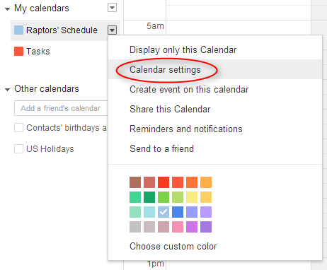

Once you're on the Schedule Details, click the Share this Calendar tab.

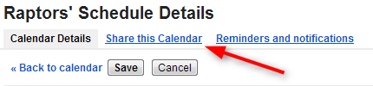

Put a check mark in the Make this calendar public box. *Note: This is necessary for other people to be able to view your calendar.
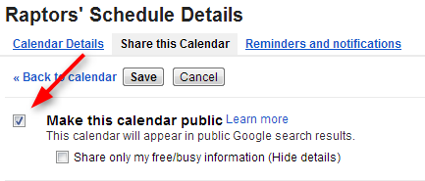
Click Save.

Click the Calendar Details tab to the left of Share this Calendar.

Scroll down to the Embed This Calendar section and copy the iframe code.

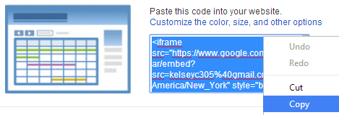

Flip back over to your Blue Sombrero site. Paste the iframe code in the Google Calendar "Embed This Calendar" text box on the Team Settings page.

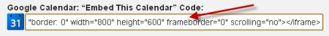

Click Update at the bottom of the page.

Click on your Team Name at the top of the page. Then click on the Calendar tab to view your new calendar.

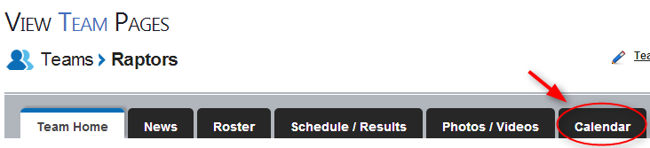

Below is an example of what your calendar will look like. *Note: You may have to clear your cache by holding down CTRL+F5 on your keyboard to view the calendar.

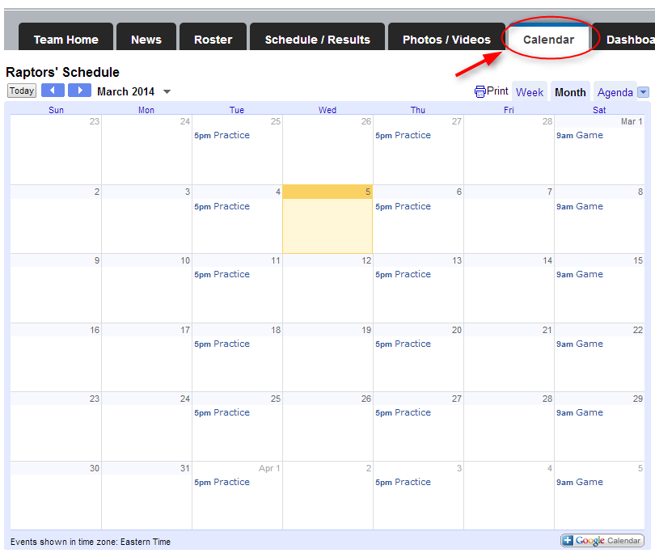

If you have any questions, contact Jillian Anderson or Jon Carlston at webadmin@carlsbadyouthbaseball.org

